Meridian plane
# Source: AI Source: Provided by: [Data Path: Persons Table -> ID Column: 1, Name_En Column: Motasem Essam] -> From: [ChatGPT] on [7/25/2026]
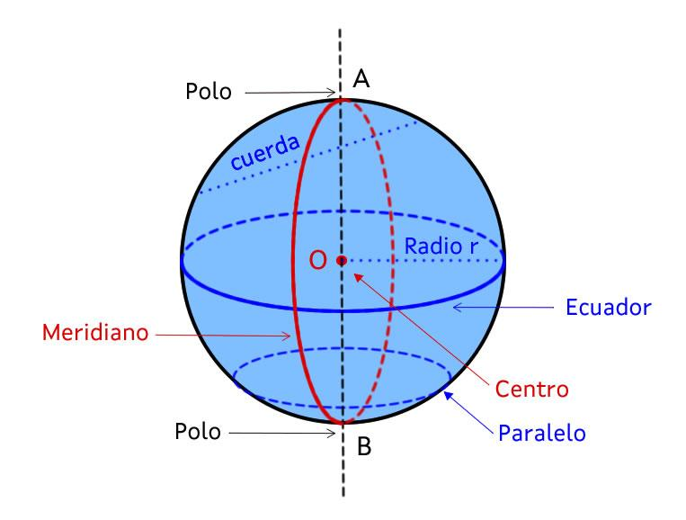
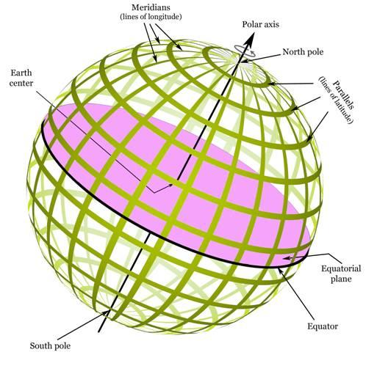
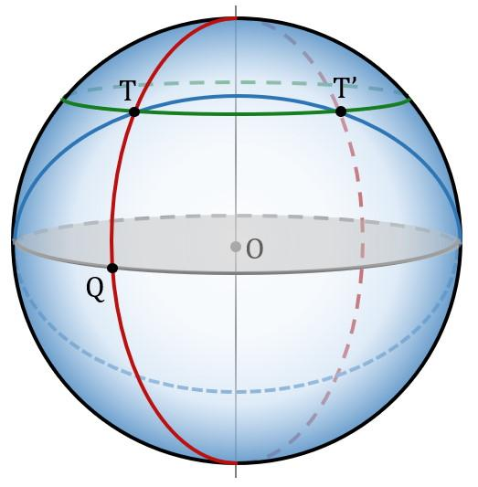

Definition
# Source: AI Source: Provided by: [Data Path: Persons Table -> ID Column: 1, Name_En Column: Motasem Essam] -> From: [ChatGPT] on [7/25/2026]
A meridian plane is a plane that passes through the center of a sphere and contains its chosen axis of rotation. Its intersection with the sphere's surface forms a great circle called a meridian or meridional great circle.
For Earth, a meridian plane contains Earth's rotational axis and passes through both the North Pole and the South Pole. It intersects Earth's surface along a meridian.
A meridian plane is not the same as the equatorial plane: the equatorial plane is perpendicular to the rotational axis, whereas a meridian plane contains that axis.

Simple Definition
# Source: AI Source: Provided by: [Data Path: Persons Table -> ID Column: 1, Name_En Column: Motasem Essam] -> From: [ChatGPT] on [7/25/2026]
A meridian plane is an imaginary plane that cuts through the middle of a sphere and contains its north–south axis.
It divides the sphere into two equal halves.

Geometric Representation
# Source: AI Source: Provided by: [Data Path: Persons Table -> ID Column: 1, Name_En Column: Motasem Essam] -> From: [ChatGPT] on [7/25/2026]
A meridian plane has the following geometric properties:
- Center: It passes through the sphere's center $O$.
- Axis: It contains the chosen rotational axis.
- Poles: For a sphere with designated north and south poles, it passes through both.
- Intersection: It cuts the spherical surface along a great circle.
- Division: It separates the sphere into two equal hemispheres.
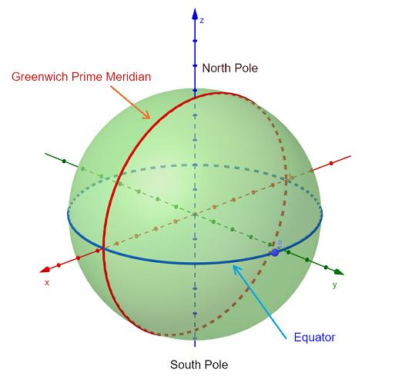
The meridian plane may have any orientation around the rotational axis. Rotating it around that axis produces different meridian planes.

Mathematical Representation
# Source: AI Source: Provided by: [Data Path: Persons Table -> ID Column: 1, Name_En Column: Motasem Essam] -> From: [ChatGPT] on [7/25/2026]
Consider a sphere centered at the origin with radius $R$, whose rotational axis is the $z$-axis.
The sphere's equation is
$$x^{2}+y^{2}+z^{2}=R^{2}$$
A meridian plane can be represented by
$$\boxed{y\cos{θ}-x\sin{θ}=0}$$
where $θ$ determines the plane's orientation around the $z$-axis.
For example, when $θ=0$, the meridian plane is
$$\boxed{y=0}$$
Its intersection with the sphere is
$$\boxed{x^{2}+z^{2}=R^{2}, y=0}$$
This intersection is a great circle containing the north and south poles.

Key Characteristics
# Source: AI Source: Provided by: [Data Path: Persons Table -> ID Column: 1, Name_En Column: Motasem Essam] -> From: [ChatGPT] on [7/25/2026]
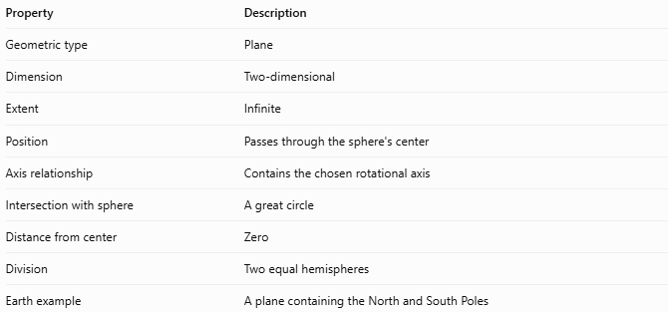
Property | Description
Geometric type | Plane
Dimension | Two-dimensional
Extent | Infinite
Position | Passes through the sphere's center
Axis relationship | Contains the chosen rotational axis
Intersection with sphere | A great circle
Distance from center | Zero
Division | Two equal hemispheres
Earth example | A plane containing the North and South Poles

Worked Example
# Source: AI Source: Provided by: [Data Path: Persons Table -> ID Column: 1, Name_En Column: Motasem Essam] -> From: [ChatGPT] on [7/25/2026]
Problem: A sphere has radius $5\text{ cm}$, is centered at the origin, and has its rotational axis along the $z$-axis. Find the equation of a meridian plane and its intersection with the sphere.
Step 1 — Choose a meridian plane
Choose the plane $y=0$, which contains the $z$-axis.
$$\boxed{y=0}$$
Step 2 — Substitute into the sphere equation
The sphere is
$$x^{2}+y^{2}+z^{2}=25$$
Setting $y=0$ gives
$$x^{2}+z^{2}=25$$
Therefore, the intersection is
$$\boxed{x^{2}+z^{2}=25, y=0}$$
Step 3 — Identify the intersection
The intersection is a great circle of radius $5\text{ cm}$, with circumference
$$C=2πR=10π\text{ cm}$$

Meridian Plane vs. Equatorial Plane
# Source: AI Source: Provided by: [Data Path: Persons Table -> ID Column: 1, Name_En Column: Motasem Essam] -> From: [ChatGPT] on [7/25/2026]
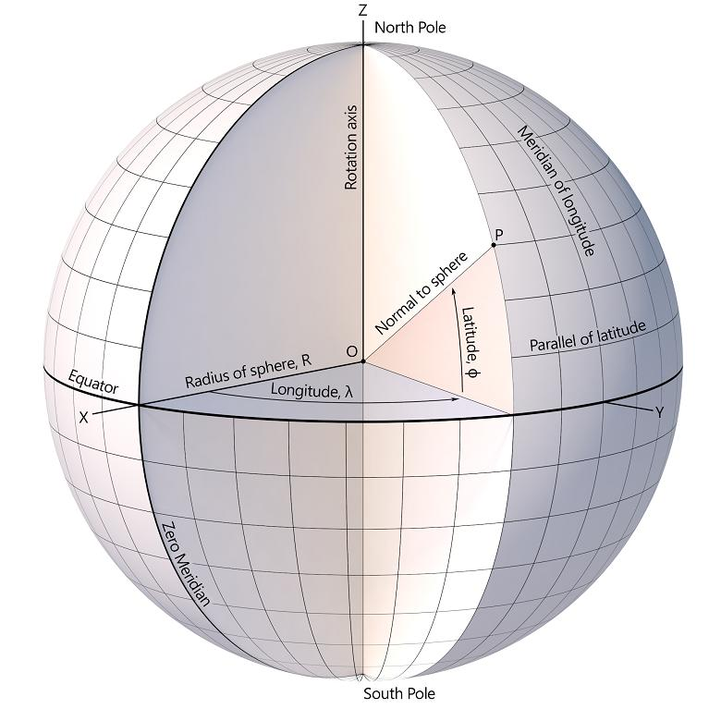
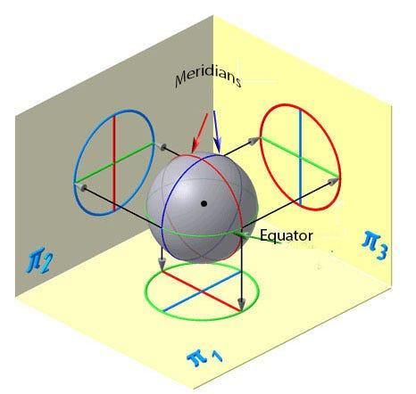
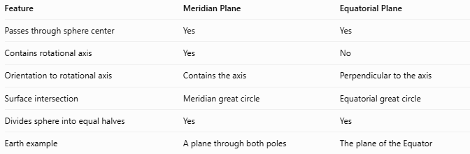
Feature | Meridian Plane | Equatorial Plane
Passes through sphere center | Yes | Yes
Contains rotational axis | Yes | No
Orientation to rotational axis | Contains the axis | Perpendicular to the axis
Surface intersection | Meridian great circle | Equatorial great circle
Divides sphere into equal halves | Yes | Yes
Earth example | A plane through both poles | The plane of the Equator

Applications
# Source: AI Source: Provided by: [Data Path: Persons Table -> ID Column: 1, Name_En Column: Motasem Essam] -> From: [ChatGPT] on [7/25/2026]
- Geography: Defining meridians of longitude.
- Navigation: Establishing north–south reference directions.
- Astronomy: Defining planes containing the rotational axis of a celestial body.
- Solid geometry: Studying great circles and spherical symmetry.
- Computer graphics: Creating spherical coordinate grids and globe models.

Key Points
# Source: AI Source: Provided by: [Data Path: Persons Table -> ID Column: 1, Name_En Column: Motasem Essam] -> From: [ChatGPT] on [7/25/2026]
- A meridian plane passes through the center of a sphere.
- It contains the sphere's chosen rotational axis.
- Its intersection with the sphere is a great circle.
- On Earth, it passes through the North Pole and South Pole.
- Different orientations around the rotational axis produce different meridian planes.
- It differs from the equatorial plane, which is perpendicular to the rotational axis.

Conclusion
# Source: AI Source: Provided by: [Data Path: Persons Table -> ID Column: 1, Name_En Column: Motasem Essam] -> From: [ChatGPT] on [7/25/2026]
The meridian plane is a plane passing through a sphere's center and containing its chosen rotational axis. It intersects the spherical surface along a great circle and divides the sphere into two equal halves. On Earth, meridian planes provide the geometric basis for meridians of longitude and the north–south reference system.

